## **A.C. DRIVING MACHINERY AND EQUIPMENT**

DESCRIBE THE PRINCIPLES OF A ROTATING FIELD.

PRINCIPLE OF ROTATING FIELD

The principle of operation in an A.C. motor is that the A.C. applied to the motor generates a rotating magnetic field and this rotating magnetic field causes the rotor of the motor to turn.

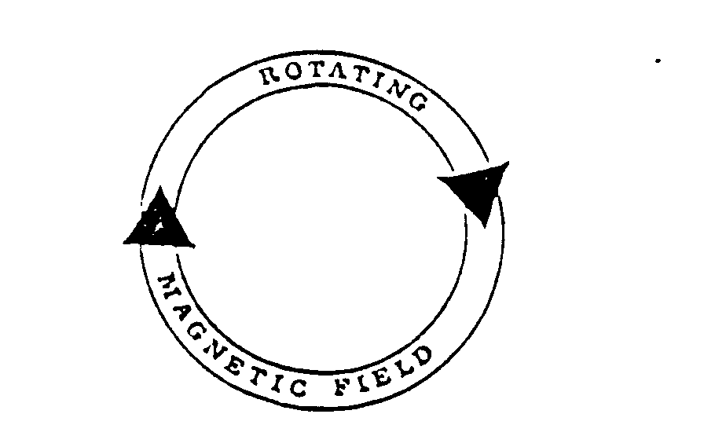

Principle of operation - an A.C. motor can be designed to operate from a single - phase A.C. supply or from a multi-phase; it operates on the same principle.

In our “foreword” we said that A.C. motors are generally classified into two types, namely:

- Synchronous motors, and

- Induction motors.

The synchronous motor is an alternator operated as a motor, in which A.C. is supplied to the stator and D.C. is applied to the rotor.

The induction motor differs from the synchronous motor in that it does not have its rotor connected to any source of power.

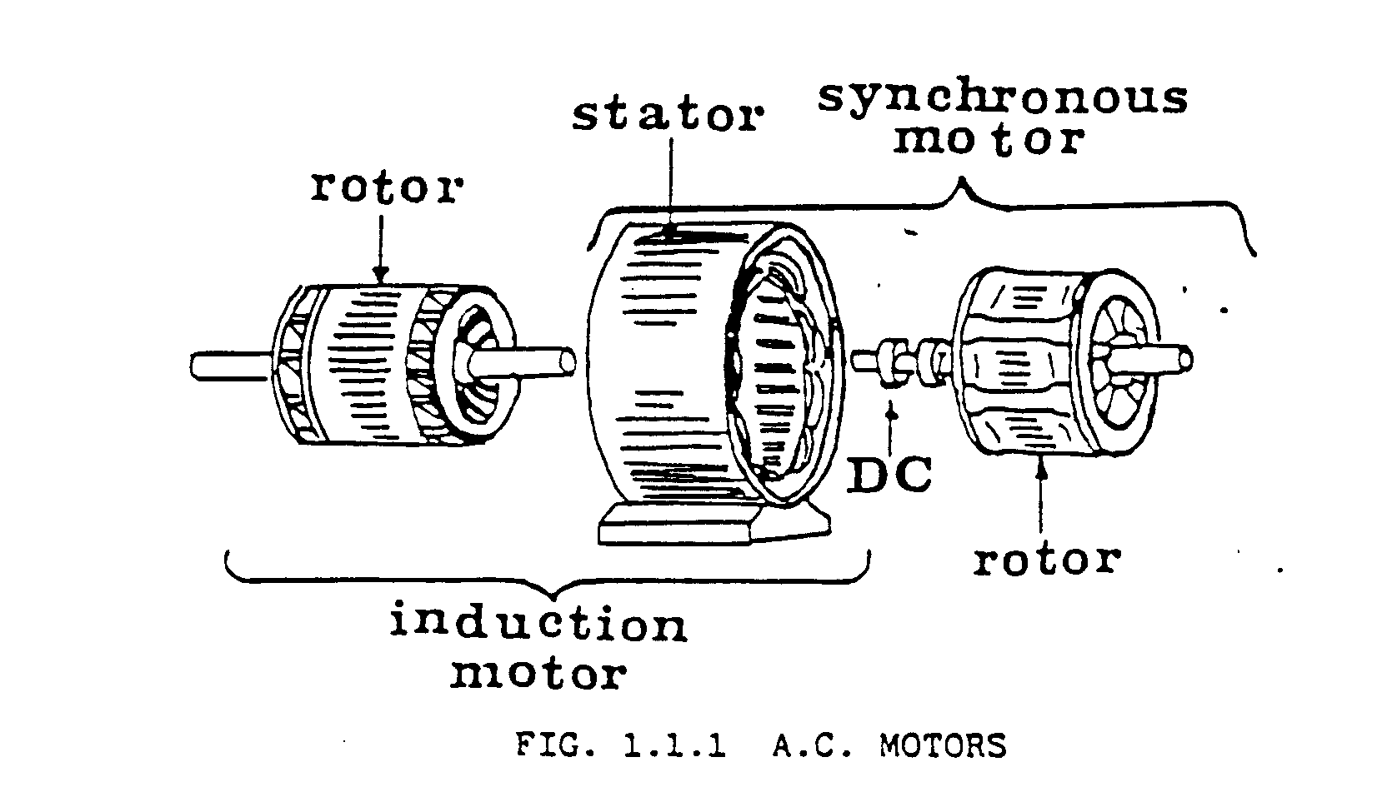

1.1 Rotating Field

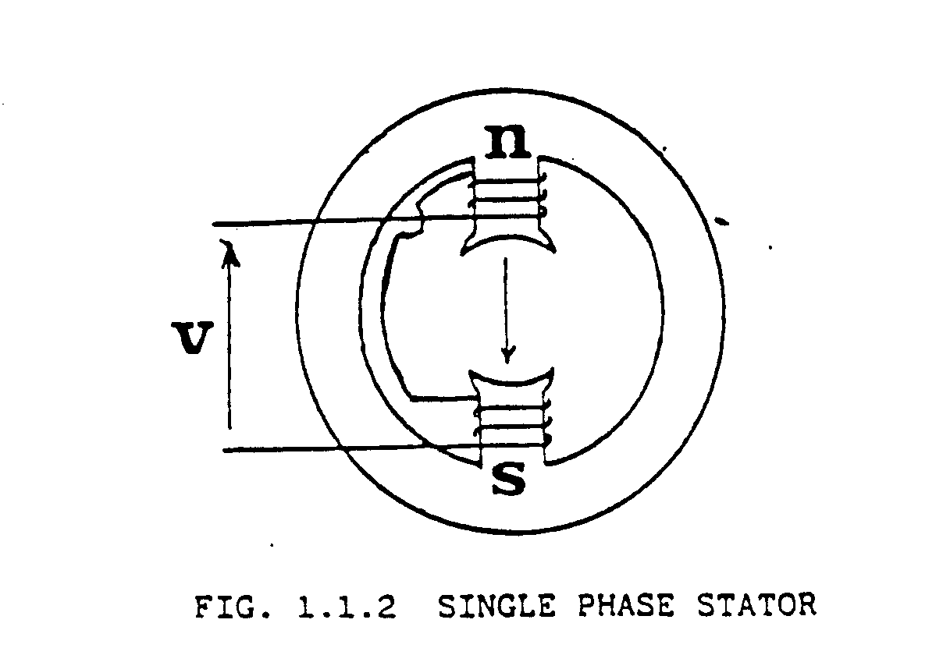

Let us now consider what a rotating field is before learning how a rotating magnetic field will cause an energised rotor to turn.

The diagram illustrates a single - phase stator to which single - phase A.C. is applied.

As can be seen from the diagram a single-phase induction motor has only one stator winding. The coils are wound in opposite directions around the poles to give a change in polarity.

The direction of the magnetic field is indicated by the arrow between the poles.

With the applied A.C. voltage alternating, the winding generates a field, which can be said to alternate along the axis of the single winding. Therefore as the voltage reverses, so the North and South Pole reverse in polarity, i.e. ALTERNATE. At this point no direction can be given.

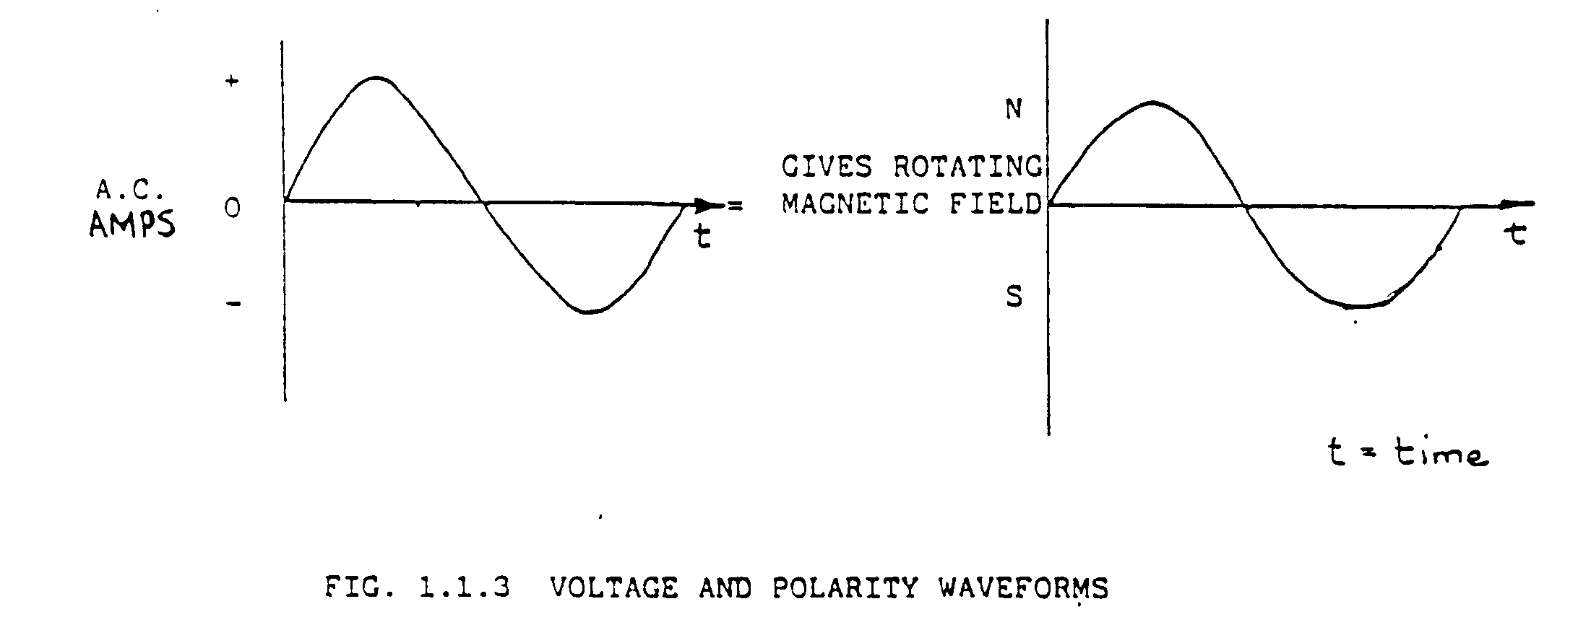If we consider an A.C. voltage waveform we thus have the following affect:

If we should take a bar magnet which could turn on an axis, and place it in the stator with an applied A.C. voltage producing this magnetic filed, it will rotate if flicked by hand in a certain direction.

Let us now take a 3 phase A.C. voltage applied stator and see what happens.

Remember, whether the motor is a single-phase or multi-phase it operates on the same principle.

THE PRINCIPLE OF A ROTATING FIELD.

The rotating field is produced a s follows:

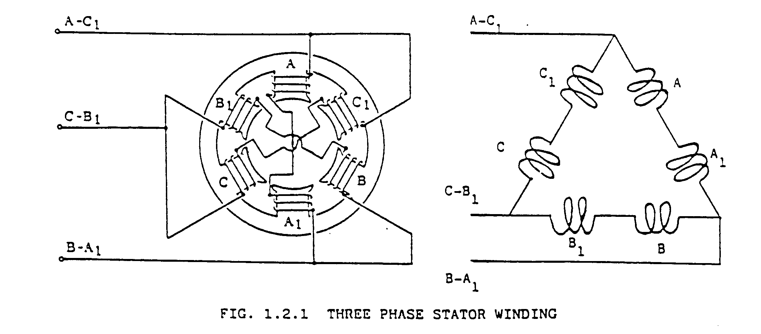The diagram in Figure 1.2.1 illustrates a three-phase stator to which three phase A.C. Voltage is applied. The windings are all connected in delta. The two windings in each phase are wound in the same direction.

It is important to realise that at any instant the magnetic field generated by one particular phase depends on the current through that phase. If the current is zero, the magnetic field is also zero and if the current is a maximum, the magnetic field is also a maximum.

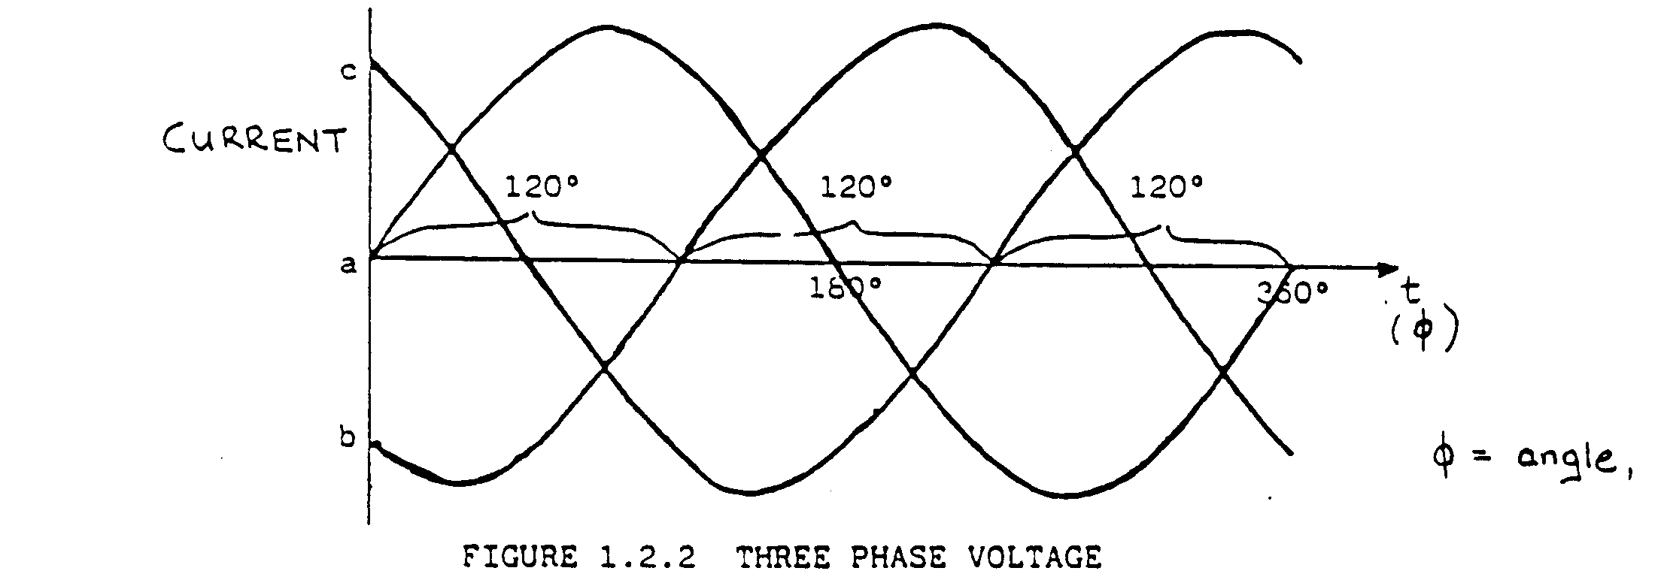

Figure 1.2.2 is an illustration of a 3-phase A.C. supply over one cycle. It can be seen that the three phases are 120 degrees out of phase. Since the currents are 120 degrees out of phase, the magnetic fields generated will also be 120 degrees out of phase. The three magnetic fields that exist at any instant combine to produce a resultant filed, which acts on the rotor.

In Figure 1.2.3 you will see that from one instant to the next, the magnetic fields combine to produce a magnetic field whose position is shifting. You will see that at the end of one complete cycle of the A.C. supply, the magnetic field will have shifted through 360 degrees or one revolution.

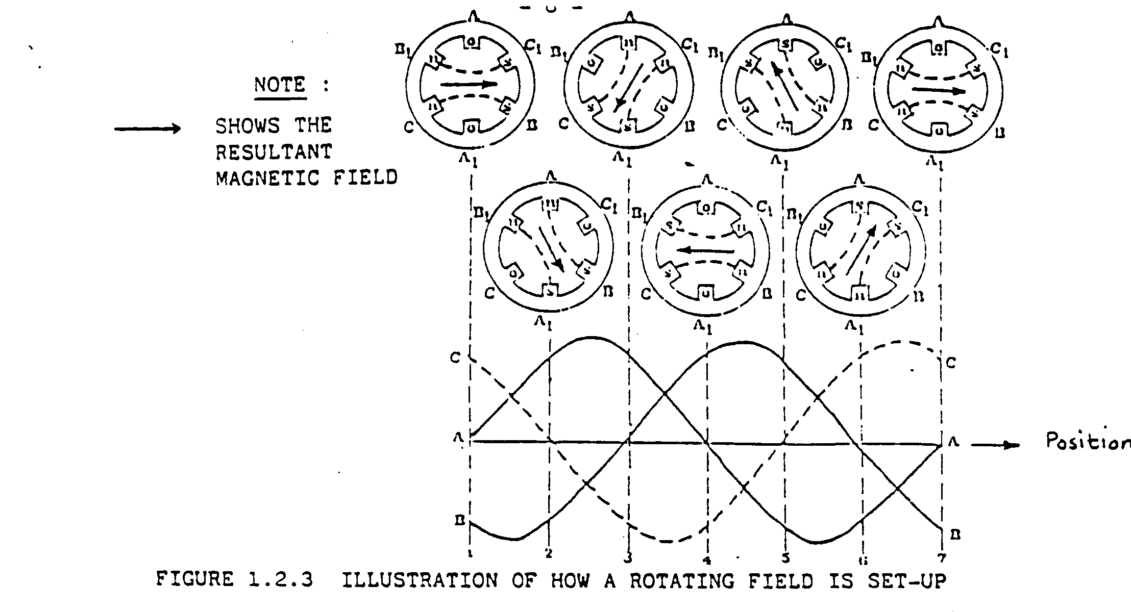Figure 1.2.3 shows the direction of the resultant magnetic field at 7 stages in one cycle of the

A.C. supply. Consider the waveforms as representing the currents flowing in the phase.

By using the waveform, we can combine the magnetic fields generated every 60 degrees to determine the resultant magnetic field.

At position 1, no current is flowing in phase A; the current flowing in phase c is positive and that flowing in phase B negative. This means that the current flows in opposite directions through phases B and C. This current establishes the magnetic polarity of phase B and C as illustrated in the diagram above point 1. Observe that B is a north pole, B is a south pole, C is a north pole and C is a south pole.

Since at point 1 there is no current flowing through phase A its magnetic filed is zero. The magnetic fields leaving the north poles Band C tend to move towards the nearest south poles Cand B as shown. Since the magnetic fields of B and C are equal in amplitude, the resultant magnetic field is indicated with an arrow.

At point 2, 60 degrees later the currents flowing in phase A and B are equal and opposite, and the current in C zero. The resultant magnetic field has rotated through 60 degrees and is in the direction as indicated by the arrow in the simple diagram above position 2.

At point 3, the currents flowing in phase A and C are equal and opposite and the current in B is zero. The resultant magnetic field has rotated through another 60 degrees.

If you consider the direction at point 4 and 7 you will see that the directions of the magnetic field rotates each time with 60 degrees.

Thus from point 1 to 7, which corresponds to one A.C. cycle, you can see that the resultant magnetic field rotates through one revolution for every cycle of A.C. supplied to the stator.

From the above explanation it should be clear that the application of three phases A.C. to three windings symmetrically spaced around a stator causes a rotating magnetic field to be generated.

CHANGING THE DIRECTION OF ROTATION OF AN A.C. MOTOR.

Since the operation of the A.C. motor depends on the principle of the rotating field, the direction of rotation of the motor can be changed by changing the direction of rotation of the rotating magnetic field set up in the stator.

The direction of rotation can be changed by changing any two of the three phases of the three-phase supply.

POWER FACTOR

Since the term POWER FACTOR is always mentioned where A.C. machines are used, let us consider what POWER FACTOR is.

We are familiar with the fact that in purely resistive D.C. Circuit operating under steady conditions of current flow, the power delivered to (and absorbed by) the circuit is equal to the product of applied volts and the current flowing in the circuit, i.e. the product of volts and amps, i.e.

Power P = V x I (watts) (or V x I kW)

 1000

This simple relationship exists because in a D.C. circuit operating under steady conditions, the voltage and current are not Fluctuating, and the current is always flowing in the direction corresponding to the polarity of the applied voltage, i.e. from the positive (+) to the negative (-) terminal of the applied voltage, through the circuit. In this case, the current is limited only by the resistance in the circuit, and the power in watts (or kW) is the same as the volt-amperes in Va (or kVa) in the circuit, i.e.

Power, P = V x I watts (or V X I kW)

1000

and P = volt amperes (or V x I kVa)

1000

However, in an alternating current (ac) circuit, the power absorbed by the circuit is not normally equal to the volt-amperes (or kVa) in the circuit. This is due to the presences in the circuit of additional circuit impedance elements (over and above the resistance of the circuit), which only make their presence felt when the voltage and /or current in the circuit are fluctuating in value with respect to time.

COSTS ASSOCIATED WITH LOW POWER FACTOR

The ideal situation is to have a power factor of 1 (100%), where all the supplied power is used to do active work. Due to the inductance of a motor this is not possible, but one should try and keep the power factor as large as possible because the idle (reactive) power is also power paid for. This is because the supply authority frequently applies a “maximum demand” charge based on the APPARENT power, i.e. the maximum kVa reached during any month. This is done because the supply authority’s generating and distribution equipment has to be sized to handle the APPARENT power.

Even when the maximum demand charge is based on the real power, i.e. maximum kW, a small amount of power can be saved by improving the power factor, because the resulting reduction in current resulting from such an improvement will lower the resistive losses in the cables, transformer windings, etc. (i.e. the IR losses of the installation), which will then absorb less “real” power from the supply.